- Introduction:
Project Name: WaterMinder – Smart Hydration Tracking & Wellness Application

- Objectives:
The WaterMinder Mobile Application aims to help users stay hydrated throughout the day by providing personalized water-intake goals, smart reminders, hydration tips, and detailed logging features. The application focuses on improving user wellness by monitoring daily water consumption, sending timely vibration/notification reminders, offering actionable hydration advice via a Tips API, and storing user data efficiently using Room Database.
- Target Users:

- Fitness Enthusiasts
  - Office Workers / Desk Job Employees
  - Elderly Individuals
  - General Health-Conscious Users
  - Athletes & Sportspersons
  - People living in hot climates
  - Users wanting daily habit tracking
  - Individuals facing dehydration or fatigue issues

- System Diagram

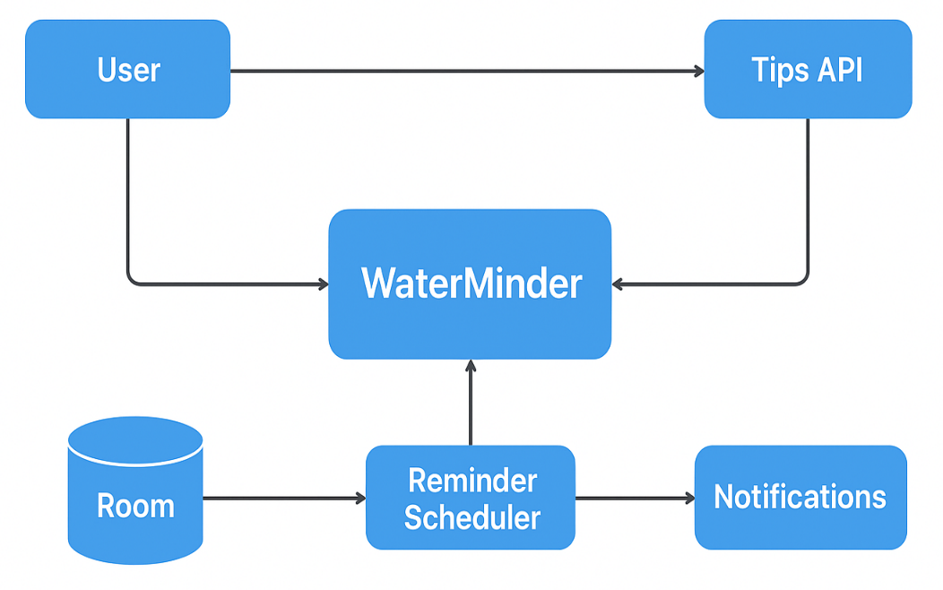
Figure 1: System Design

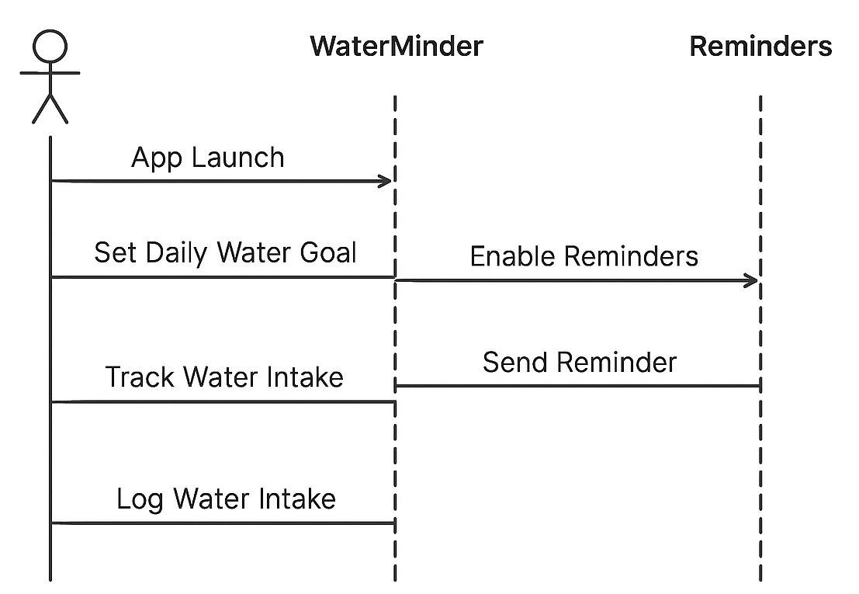
Figure 2: Sequence Diagram

- Sprint Plans:
Add your own github or treebo link

- Sprint:1
During Sprint-1, the primary focus was to define the core features of WaterMinder, gather system requirements, and design the fundamental UI flow for hydration tracking. Initial Jetpack Compose screens such as Splash Screen, Onboarding, Water Goal Setup, and Daily Tracking UI were designed and implemented. Core modules like local data storage using Room and notification channels for reminders were also initialized.
User stories:
• As a user, I want to set my daily water-intake goal so that the app can track and remind me accordingly.
• As a health-conscious individual, I want timely vibration/notification reminders so that I remember to drink water during the day.
• As a user, I want simple and clean UI screens so that I can log my water intake quickly and efficiently.
• As a wellness learner, I want hydration tips so that I can improve my daily hydration habits.
• As an app user, I want my water logs to be saved locally using Room so that I can view my past hydration history.

